Invasive Plants, Bamboo & Buyer Risk

What Conveyancers Need to Know

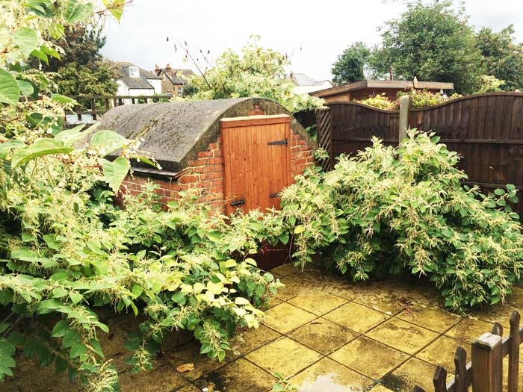
Japanese knotweed remains the most recognised invasive plant risk in UK property transactions.
Recent television coverage of invasive garden plants — particularly bamboo — has brought the issue back into the publics mind. For conveyancers, however, this is not simply a gardening story. It is increasingly a transactional risk issue.
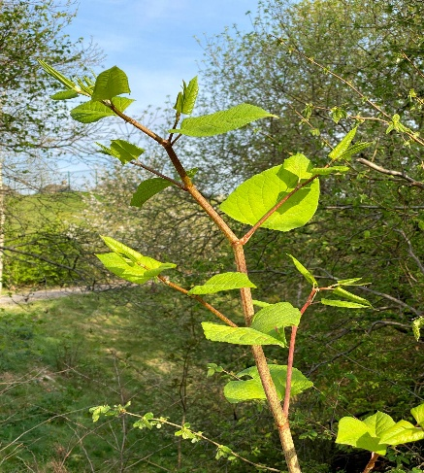
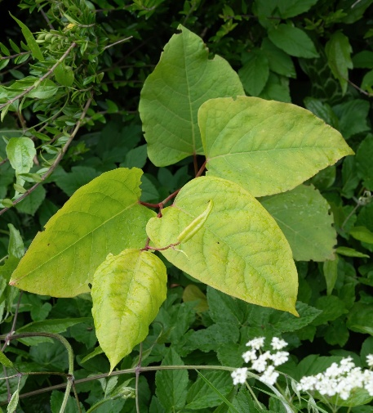
Most practitioners are familiar with Japanese knotweed and the long-standing lender sensitivities surrounding it. However, knotweed is only part of a wider and evolving landscape. Increasingly, other fast-spreading species — including certain forms of bamboo and Horsetail — are appearing in survey reports, property enquiries and neighbour disputes.
The key question for conveyancers is not whether these plants exist, but how they translate into risk for buyers, lenders and future liability.

Bamboo – Attractive Screening or Emerging Liability?
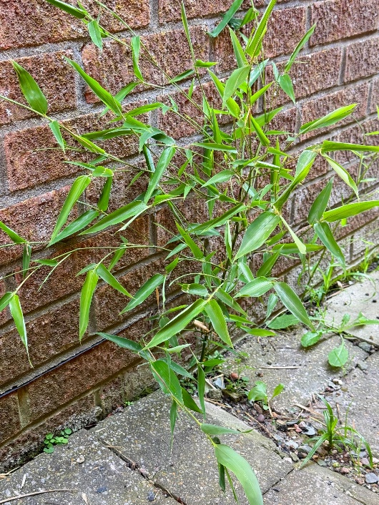

Running bamboo varieties can spread rapidly via underground rhizomes, sometimes extending well beyond the original planting area.
Bamboo is often marketed as an attractive and low-maintenance screening plant. In reality, some “running” varieties spread aggressively via underground rhizomes, travelling several metres beyond where they were first planted.
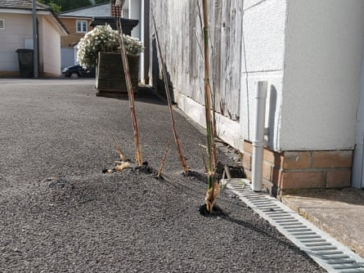
Unlike knotweed, bamboo is not currently listed under the Wildlife and Countryside Act 1981 as a controlled invasive species. However, this does not mean it is without risk.
Issues increasingly reported include:
- Encroachment into neighbouring gardens
- Damage to patios, paths and lightweight structures
- Boundary disputes arising from root spread
- Costly specialist removal programmes
From a legal perspective, the problem frequently becomes one of private nuisance rather than statutory control. Where roots encroach and cause damage, liability can arise — sometimes years after completion.
For buyers, the distinction between a decorative garden feature and a potential legal dispute is rarely obvious.

A Broader Invasive Landscape

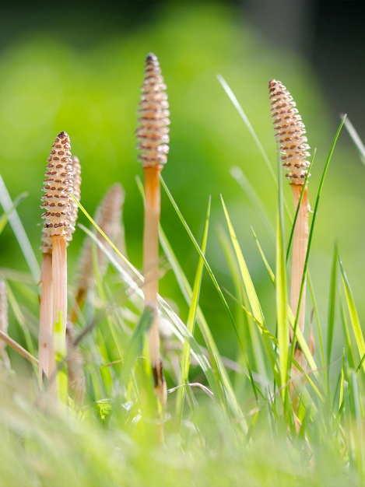
Horsetail is extremely resilient, with deep root systems that make eradication difficult.
While Japanese knotweed remains the most high-profile plant in conveyancing, the underlying concern is consistent: structural risk, mortgage security and remediation uncertainty.
Alongside knotweed, conveyancers are encountering a wider range of problematic species, including:
- Horsetail — a resilient plant with deep root systems that are notoriously difficult to eradicate
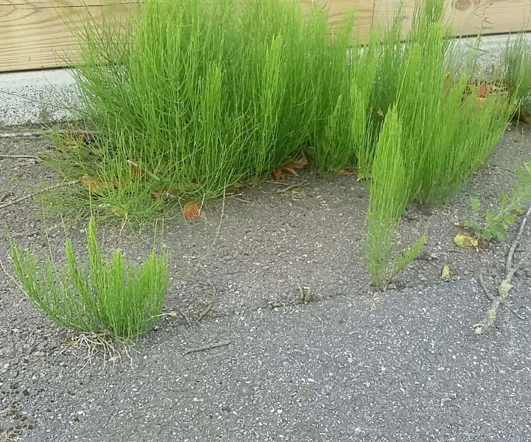
- Running bamboo varieties capable of rapid lateral spread
- Giant hogweed, which can present health hazards and potential enforcement issues
The legal framework varies between species, but the transactional risks often arise from:
- Disclosure issues on the TA6 Property Information Form
- Surveyor down-valuations
- Mortgage lender requirements for treatment plans
- Historic or ongoing neighbour disputes
In practice, it is often lender reaction and disclosure obligations, rather than the plant itself, that create delay or renegotiation within a transaction.

What Will Searches Reveal?
A common assumption is that invasive plants will appear in a standard local authority search. In reality, most planting issues will not appear unless they have triggered formal enforcement action or environmental health involvement.
Environmental searches may highlight certain environmental risk factors or known treatment sites associated with knotweed. However, bamboo and horsetail rarely appear in search datasets unless linked to official intervention.
Searches cannot see every root system beneath the soil. What they can do is provide context by:
- Identifying environmental risk indicators
- Highlighting historic enforcement activity
- Supporting informed follow-up enquiries where appropriate
As environmental risks become more varied, interpretation of search information remains as important as the data itself.

The TA6 Disclosure Gap
The TA6 Property Information Form specifically asks sellers whether the property is affected by Japanese knotweed. It does not ask about bamboo or other invasive species.
This creates a potential disclosure gap.
If a seller is aware that bamboo has caused neighbour complaints or that removal has been attempted unsuccessfully, failing to disclose the issue could potentially give rise to misrepresentation claims after completion.
Where surveyors raise concerns about aggressive planting near boundaries or structures, conveyancers may wish to consider targeted enquiries or specialist reports.

A Measured Approach
It is important not to create unnecessary alarm. Many properties contain bamboo or other vigorous planting that remains well managed and entirely problem-free.
However, as environmental awareness grows and buyers become more cautious, invasive plants are likely to appear more frequently in conveyancing enquiries.
The conveyancer’s role is not to become a horticultural expert, but to recognise when a garden feature may cross the line into legal, lending or neighbour dispute risk.
As with many conveyancing issues, early identification and clear advice remain the most effective way of managing potential problems before they become costly disputes.

Author
Andrew Prismall
HW Conveyancing Searches
HW Conveyancing Searches supports conveyancers with regulated local authority searches and environmental information, helping firms understand the context behind property risk.

